* **Customers**

1. Click Menu

Menu

1. Click Maintenance

Maintenance

1. Click Customers

Customers

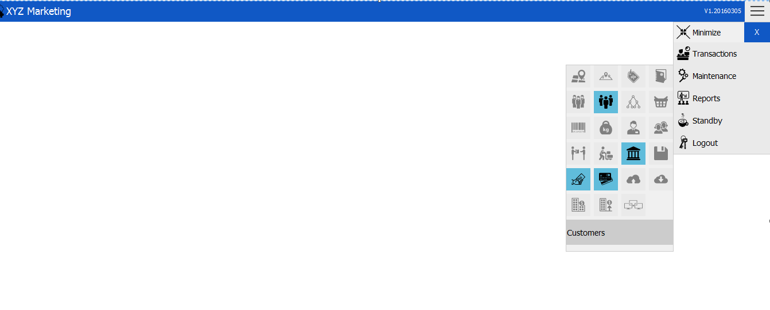

* **Customer Transaction**

1. Input customer’s name
2. Input customer’s contact number
3. Input customer’s address
4. Click “Add” if you want to add, “Update” if you want to update and “Delete” if you want to remove.

Name

Add

Update

Delete

Address

Contact Number

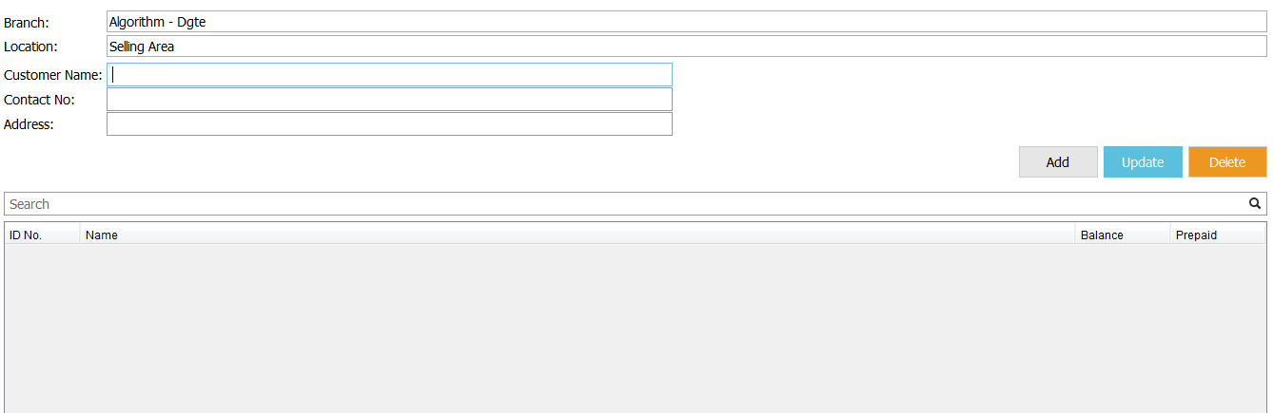

Search

1. Input customer’s name.



1. Input customer’s contact number.



1. Input customer’s address.



1. Add

**After filling up the customer’s name, contact number and address, just click the “Add” button on the upper right side of your screen to add to list.**



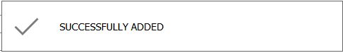

**This message box will appear if you successfully added to the list.**

1. Update

**If you want to update information, just click the “Update” button between your add and delete buttons.**



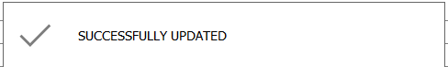

**This message box will appear if you successfully updated.**

1. Delete

**If you want to delete customer from the list, click the “Delete” button beside update button.**



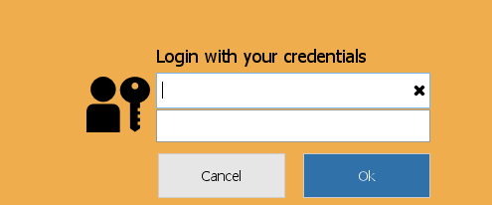 Note: **Only privilege users can delete customers.**

1. Search



**Input on the search bar the name you want to search.**

**You can also press enter to view all customers list.**

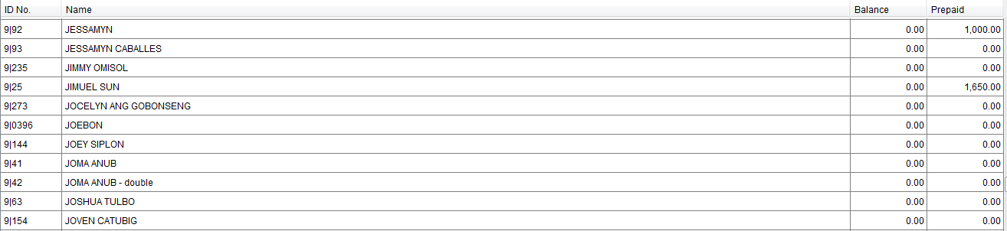

Note: Balance is the remaining credits and the prepaid are the advance payment of the customer.

* **Disbursement**

Update

Add

Delete

Category

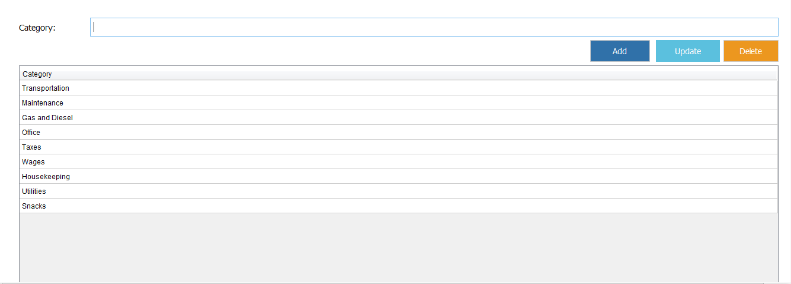

Display Area

1. Category



**Input Category you want to add, update or delete.**

1. Add

**After you type the category name, click the “Add” button to add it to list.**

1. Update

**If you want to update category, you can enter the category name on the category tab or you can just simply click the name on the display area and then click “Update” button.**



1. Delete

**Deleting is removing from the list. If you want to remove, you just click the name on the display area or type it on the category bar and then click “Delete” button.**



1. Display

**It is an area in which you can see the whole categories.**

